Rename the file to this format: M6-Lab01-yourname.docx or pdf
Class & Module | SAH  Lab01: EXPLORING DATA WITH SPARK / Assignment1
Name | Goh Rui Kun
IC No. [S****123X] | S****836J
Date & Time | 19 Feb 2021 6pm

Create screenshot following the instruction below:
Step 1 of 6
Deploy HDI Spark Cluster ; after completed, open the HDI Cluster overview and create - paste the screenshot of the HDI Cluster overview

*** place here the screenshot of your Azure HDI Cluster overview ***


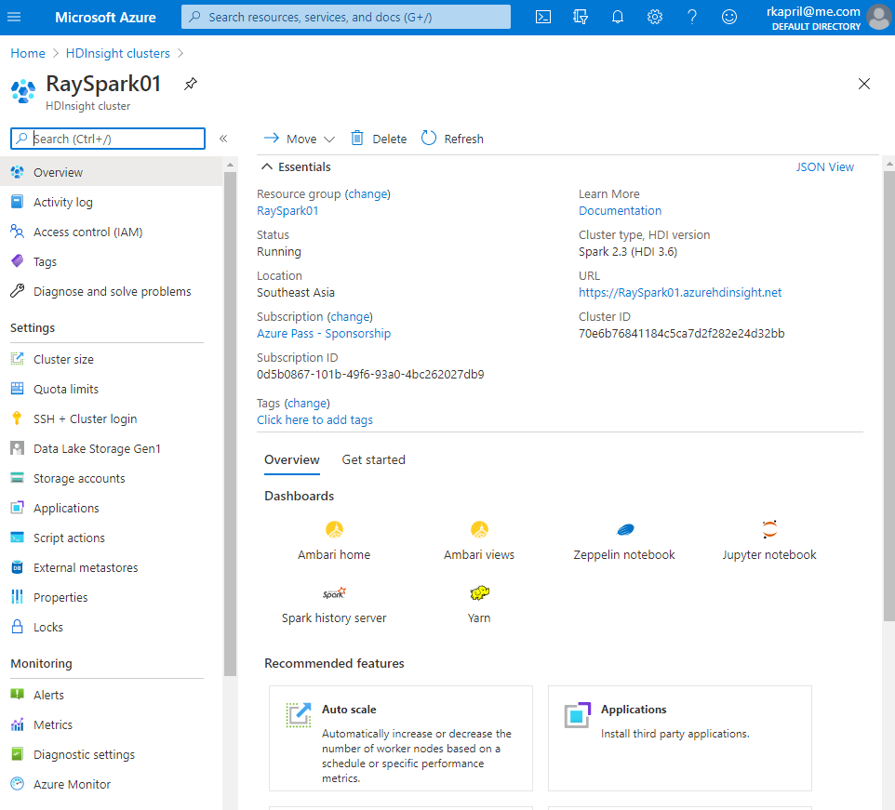

Step 2 of 6
Click to Open Jupyter Notebook and Logon and then create - paste the screenshot to show you have successfully open the Jupyter Notebook in HDI Spark.

*** place here the screenshot ***

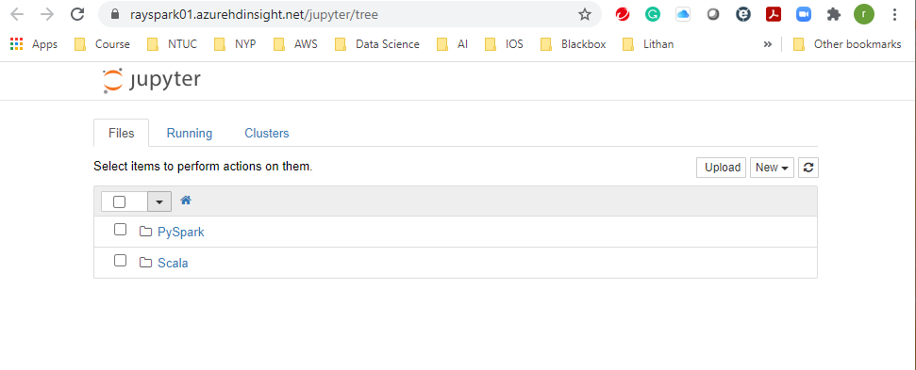
Step 3 of 6
Do this when you want to end the lab.
Open the resource group that you created as part of HDI cluster deployment, then click Delete Resource Group, after you enter the resource group name and before you click button to DELETE, create - paste the screenshot below

*** place here the screenshot ***

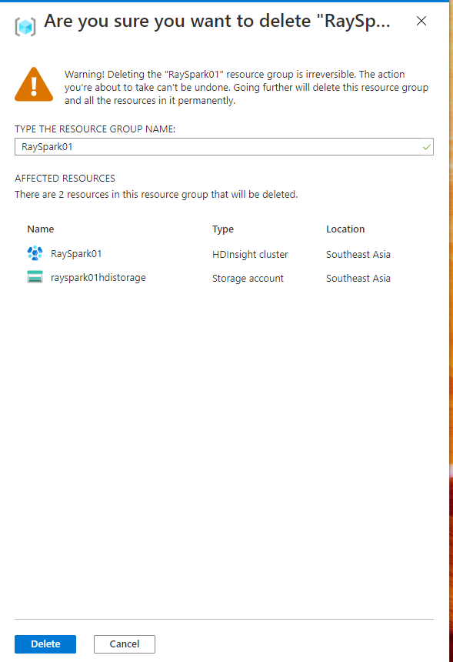

Create screenshot following the instruction below:
Step 4 of 6
Upload the CSV either using Azure Storage Explorer or Azure portal to Azure storage BLOB container in the folder named “data”
- raw-flight-data.csv
- airports.csv
create - paste the screenshot showing that the 2 CSVs had been uploaded to data folder

*** place here the screenshot of your data folder ***

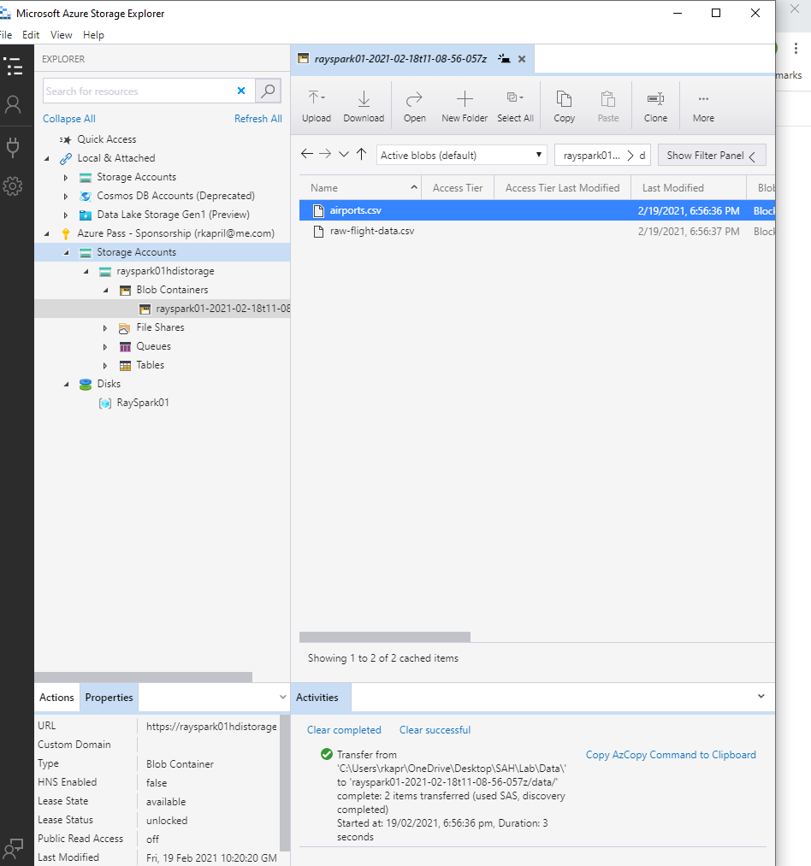
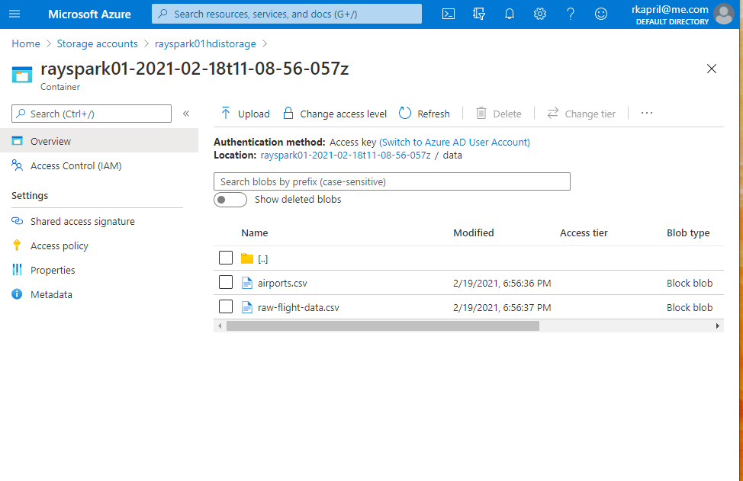

Step 5 of 6
Upload the Lab 1 Notebook: Python Data Exploration
create - paste the screenshot showing you have uploaded the notebook

*** place here the screenshot ***

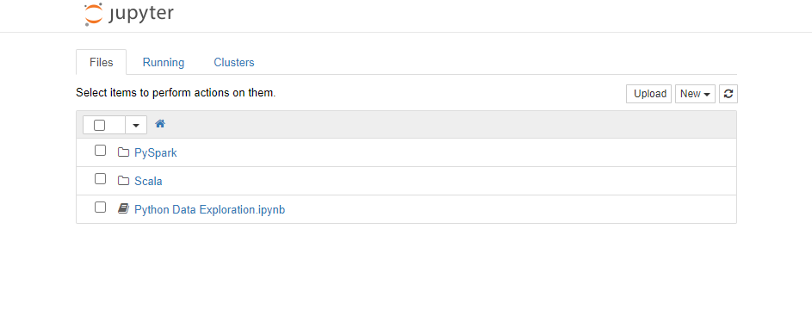

Step 6 of 6
Run and explore the notebook, cell by cell until complete
In the Spark SQL section cell, create - paste the screenshot the output of command below
data.createOrReplaceTempView("flightData")
spark.sql("SELECT DayOfWeek, AVG(ArrDelay) AS AvgDelay FROM flightData GROUP BY DayOfWeek ORDER BY DayOfWeek").show()

*** place here the screenshot ***

